


NATIONAL UNIVERSITY OF SCIENCE AND TECHNOLOGY
Militery Collage of Signals
Department of Software Engineering

CS-212Object Oriented Programming

Project Proposal

Submitted by:
Rustam Ali Shah - 432053
Muneeb ur Rehman - 432070
M. Ammar Haider -

Submitted to:
Dr Muhammad Asif

Submission Date: 02-08-2025
Title: Simple Hospital Care Management System

Purpose

1. Introduction
Hospitals manage complex data including patients, doctors, appointments, billing, and pharmacy inventory. Manual handling of these records is error-prone, time-consuming, and inefficient. The Simple Hospital Care Management System is a desktop Java application designed to streamline basic hospital operations using object-oriented principles.

2. Description
This system allows authorized users to manage patients and doctors, schedule appointments, track medical history, handle billing, and monitor medicine availability. It uses file-based persistence to store and retrieve data and demonstrates OOP concepts such as inheritance, polymorphism, encapsulation, and interfaces.

3. Objectives
- Develop a user-friendly Java application to manage hospital data.
- Demonstrate OOP concepts.
- Enable scheduling and conflict-free appointment management.
- Implement billing and patient history tracking.
- Provide search, reporting, and prioritization features.

4. Scope of the Project
The proposed system will cover the following operations:
- Patient Management – Adding, updating, deleting, and viewing patient details.
- Doctor Management – Maintaining records of doctors, including specialization and availability.
- Appointment Scheduling – Assigning patients to doctors without time conflicts.
- Billing System – Calculating and generating patient bills.
- Medicine Tracking – Monitoring available medicines in the pharmacy.
- Data Storage – Saving and retrieving records using file handling in Java.
The system will not include real-time network support or multi-branch hospital integration, as it is designed for a single hospital unit.

Functionality

5. Features
- Login System for different roles (Admin, Receptionist, Doctor).
- Patient History Tracking with previous diagnoses and treatments.
- Doctor Specialization Search to quickly match patients with the right doctor.
- Emergency Tagging for prioritizing critical cases.
- Report Generation for daily hospital activities.
- Exception Handling to prevent invalid data entries.

6. Methodology
a. Requirement Analysis
Identify entities (Patient, Doctor, Appointment, Medicine) and their interactions. Define functional and non-functional requirements, such as avoiding overlapping appointments and maintaining historical logs.
b. System Design
- Create UML-style class designs.
- Define inheritance hierarchies (e.g., Person → Doctor/Patient).
- Specify interfaces (e.g., Billable) and abstract base classes (e.g., Staff).
c. Implementation
- Use Java Collections (ArrayList, HashMap) for in-memory storage.
- Encapsulate data with private fields and expose via getters/setters.
- Implement scheduling logic to detect and prevent conflicts.
- Develop billing logic in classes implementing Billable.
- Persist data using file I/O (e.g., CSV or serialized text files).
- Add exception handling for invalid input, missing records, and I/O failures.
d. Testing
Unit tests for core functions: adding/updating entities, scheduling appointments, bill computation, and data persistence. Simulated scenarios (emergency patient handling, double booking attempts, etc.) to validate business rules.
e. Reporting & Output
Generate textual reports for daily appointments, individual patient history, and summary bills.

7. System Design Overview
The system will follow an Object-Oriented design:
- Class: Person – Base class for Patient and Doctor.
- Class: Patient – Stores personal details, disease, history, and billing information.
- Class: Doctor – Stores personal details, specialization, and assigned appointments.
- Class: Appointment – Connects patients and doctors with date and time.
- Interface: Billable – For classes that calculate bills.
- Class: HospitalManagement – Main controller to manage all operations.
The design will use Java Collections (ArrayList, HashMap) for dynamic data storage and file handling for saving records.
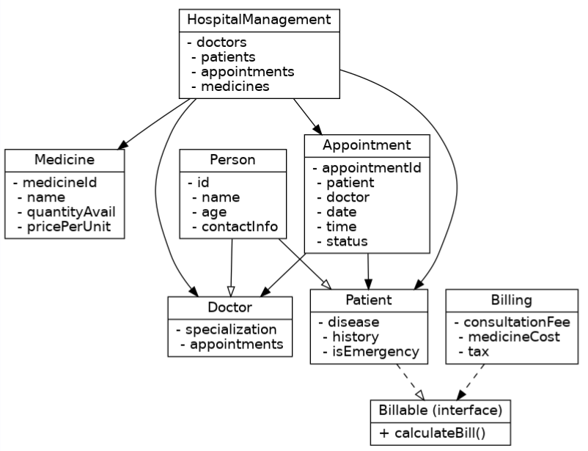

8. Expected Outcome
By the end of development, the project will deliver:
- A fully functional desktop application in Java.
- Efficient hospital record management with reduced manual work.
- Organized appointment and billing system.
- Easy-to-use GUI for smooth interaction (in later phase).

9. Limitations
- Single-user desktop application: No real-time multi-user synchronization.
- File-based storage: Lacks robustness and scalability of database-backed systems.
- Security: Basic input validation only; no encryption or authenticated session management in initial version.
- No web/mobile access: GUI will be a local desktop interface (console or Swing/JavaFX later), not web-based.
- Manual role enforcement: Role-based access (Admin/Doctor/Receptionist) will be logical and not backed by secure authentication tokens.

10. Conclusion
The Simple Hospital Care Management System is a practical application of object-oriented programming in Java aimed at solving real-world administrative challenges in healthcare. By encapsulating hospital entities into well-designed classes and leveraging OOP principles, the system offers structured data handling, conflict-free scheduling, transparent billing, and easy extensibility. Though scoped for a single-user environment with file-based persistence, it lays a solid foundation for future enhancements such as database integration, web interfaces, and multi-user concurrency.

